**Adapter Pattern**

This pattern is easy to understand as the real world is full of adapters.   For example consider a USB to Ethernet adapter. We need this when we have an Ethernet interface on one end and USB on the other. Since they are incompatible with each other. we use an adapter that converts one to other. This example is pretty analogous to Object Oriented Adapters. In design, adapters are used when we have a class (Client) expecting some type of object and we have an object (Adaptee) offering the same features but exposing a different interface.

To use an adapter:

1. The client makes a request to the adapter by calling a method on it using the target interface.
2. The adapter translates that request on the adaptee using the adaptee interface.
3. Client receive the results of the call and is unaware of adapter’s presence.

***Definition:***

The adapter pattern convert the interface of a class into another interface clients expect. Adapter lets classes work together that couldn’t otherwise because of incompatible interfaces.

**Class Diagram:**  
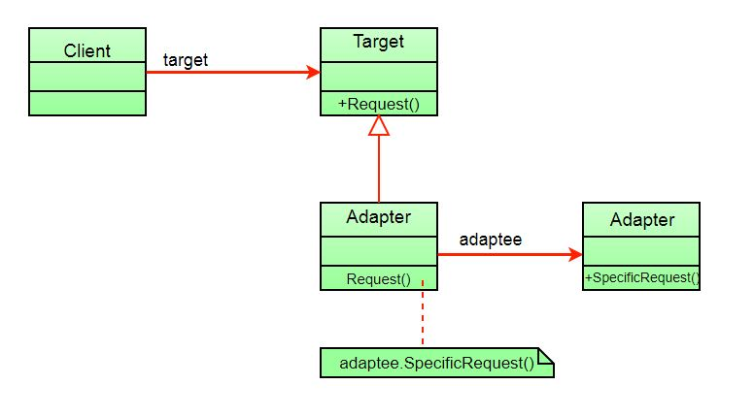

The client sees only the target interface and not the adapter. The adapter implements the target interface. Adapter delegates all requests to Adaptee.

**Example:**

Suppose you have a Bird class with fly() , and makeSound()methods. And also a ToyDuck class with squeak() method. Let’s assume that you are short on ToyDuck objects and you would like to use Bird objects in their place. Birds have some similar functionality but implement a different interface, so we can’t use them directly. So we will use adapter pattern. Here our client would be ToyDuck and adaptee would be Bird.

Below is Java implementation of it.

|  |
| --- |
| // Java implementation of Adapter pattern    interface Bird  {      // birds implement Bird interface that allows      // them to fly and make sounds adaptee interface      public void fly();      public void makeSound();  }    class Sparrow implements Bird  {      // a concrete implementation of bird      public void fly()      {          System.out.println("Flying");      }      public void makeSound()      {          System.out.println("Chirp Chirp");      }  }    interface ToyDuck  {      // target interface      // toyducks dont fly they just make      // squeaking sound      public void squeak();  }    class PlasticToyDuck implements ToyDuck  {      public void squeak()      {          System.out.println("Squeak");      }  }    class BirdAdapter implements ToyDuck  {      // You need to implement the interface your      // client expects to use.      Bird bird;      public BirdAdapter(Bird bird)      {          // we need reference to the object we          // are adapting          this.bird = bird;      }        public void squeak()      {          // translate the methods appropriately          bird.makeSound();      }  }    class Main  {      public static void main(String args[])      {          Sparrow sparrow = new Sparrow();          ToyDuck toyDuck = new PlasticToyDuck();            // Wrap a bird in a birdAdapter so that it          // behaves like toy duck          ToyDuck birdAdapter = new BirdAdapter(sparrow);            System.out.println("Sparrow...");          sparrow.fly();          sparrow.makeSound();            System.out.println("ToyDuck...");          toyDuck.squeak();            // toy duck behaving like a bird          System.out.println("BirdAdapter...");          birdAdapter.squeak();      }  } |

Output:

Sparrow...

Flying

Chirp Chirp

ToyDuck...

Squeak

BirdAdapter...

Chirp Chirp

**Explanation :**  
Suppose we have a bird that can makeSound(), and we have a plastic toy duck that can squeak(). Now suppose our client changes the requirement and he wants the toyDuck to makeSound than ?  
Simple solution is that we will just change the implementation class to the new adapter class and tell the client to pass the instance of the bird(which wants to squeak()) to that class.  
**Before :** ToyDuck toyDuck = new PlasticToyDuck();  
**After :** ToyDuck toyDuck = new BirdAdapter(sparrow);  
You can see that by changing just one line the toyDuck can now do Chirp Chirp !!

**Object Adapter Vs Class Adapter**  
The adapter pattern we have implemented above is called Object Adapter Pattern because the adapter holds an instance of adaptee. There is also another type called Class Adapter Pattern which use inheritance instead of composition but you require multiple inheritance to implement it.  
Class diagram of Class Adapter Pattern:

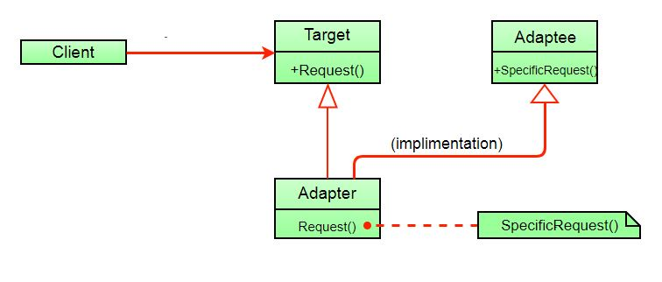

Here instead of having an adaptee object inside adapter (composition) to make use of its functionality adapter inherits the adaptee.

Since multiple inheritance is not supported by many languages including java and is associated with many problems we have not shown implementation using class adapter pattern.

**Advantages:**

* Helps achieve reusability and flexibility.
* Client class is not complicated by having to use a different interface and can use polymorphism to swap between different implementations of adapters.

**Disadvantages:**

* All requests are forwarded, so there is a slight increase in the overhead.
* Sometimes many adaptations are required along an adapter chain to reach the type which is required.